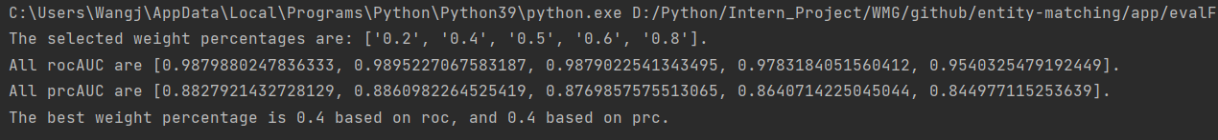

The best weight percentage here is 0.4. So the 0.4 is used for the next step